AM000-Asia-Japan-Edo-Lion and Phoenix

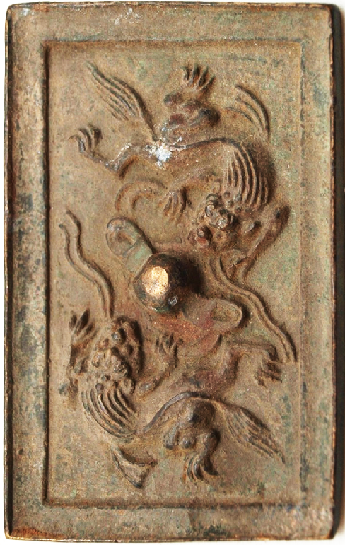

Stunning bronze Japanese mirror measuring 80mm x 50mm.  This bronze mirror has a lovely verdigris patina.  The back is decorated with primitive scenes of oriental mythical creatures.  It has a central boss which is pierced to allow a cord to be passed through for holding.  The other side is undecorated and would have originally been polished to create a reflective surface.